

UNITEDWORLD INSTITUE OF TECHNOLOGY

(UIT)

Summative Assessment (SA)

Submitted BY

Patel Zalak Bipinkumar

(Enroll. No.: 20220701020)

**Course Code and Title:**

**21BSAI99E32 [Introduction to Machine Learning]**

B.Sc. (Hons.) Computer Science

IV Semester – December – May 2024

**UIT**

March/April 2024

Contents

Project Title: 3

Aim and Objective: 3

Importance: 3

Source of Dataset: 3

Dataset Description: 3

Statistical Analysis: 4

Machine Learning Implementation: 4

OUTCOMES: 21

Conclusion: 25

Project Title:Crop Yield Prediction.

# Aim and Objective:

The Aim of this project is to apply machine learning algorithms on Crop Yield Prediction to predict crop yield which can be beneficial to farmers to enhance agriculture and have increment in growth of crops using yield prediction.

# Importance:

Importance of Crop Yield Prediction can be seen in the field of agriculture which decreases the risks for loss to farmers and use resources and their energy wisely. This models can give accurate prediction to farmers which helps them to grow crops accordingly which benefits them from wastage of resources and money. This prediction encourages profitable agriculture and helps to grow according ratio of railfall, pesticides, temperature etc which helps in beneficial farming. This can be said as a small step towards smart farming techniques which can be effective globally for good farming.

# Source of Dataset:

<https://www.kaggle.com/datasets/patelris/crop-yield-prediction-dataset>

# Dataset Description:

In this Dataset of Crop Yield Prediction:

Temperature and Rainfall data is collected from World Bank Data. In temp dataset there are 71312 rows and 3 columns and in rainfall dataset there are 6728 rows and 3 columns. Pesticides and Yield are collected from Food and Agriculture Organization in which pesticides dataset include 4350 rows and 7 columns where as yield includes 56718 rows and 12 columns.

Further, after cleaning and merging this data yield_df is created using necessary columns and rows from temperature, pesticides, rainfall, yield and final dataset is created. There are 28243 rows and 8 columns in Yield_df which is used for our project. Column names in yield_df include Area, item, year, hg/ha_yield, average_rainfall_mm_per_year, pesticides_tonnes, avg_temp.

Area: this column indicates country.

Item: it indicates the name of crops.

Year: it presents year in which crop was sown.

Hg/ha_yield: this field indicates yield hectogram per hectare.

Rainfall_mm_per_year: It indicates amount of rainfall in mm per year

Pesticides_tonnes: shows the amount of pesticides used in crop per year

Avg_temp: indicates the average temperature of the area.

# Statistical Analysis:

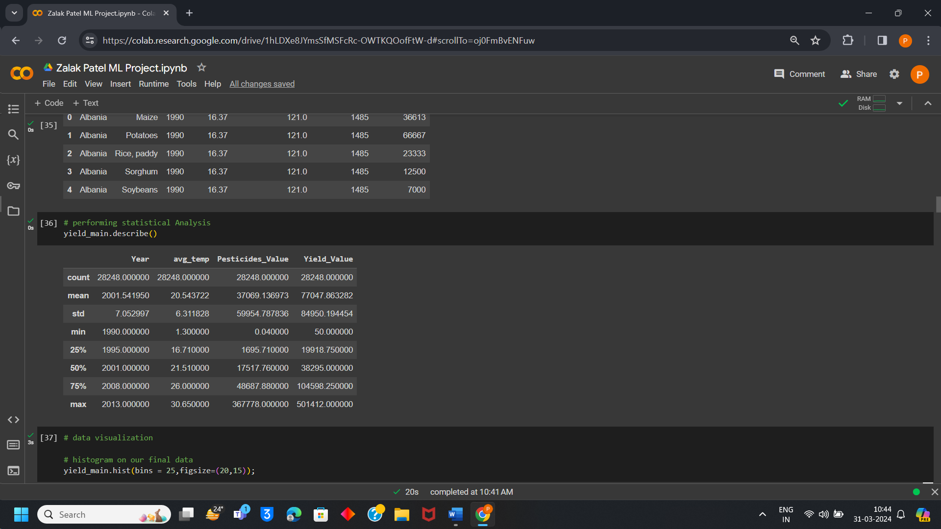

# Machine Learning Implementation:

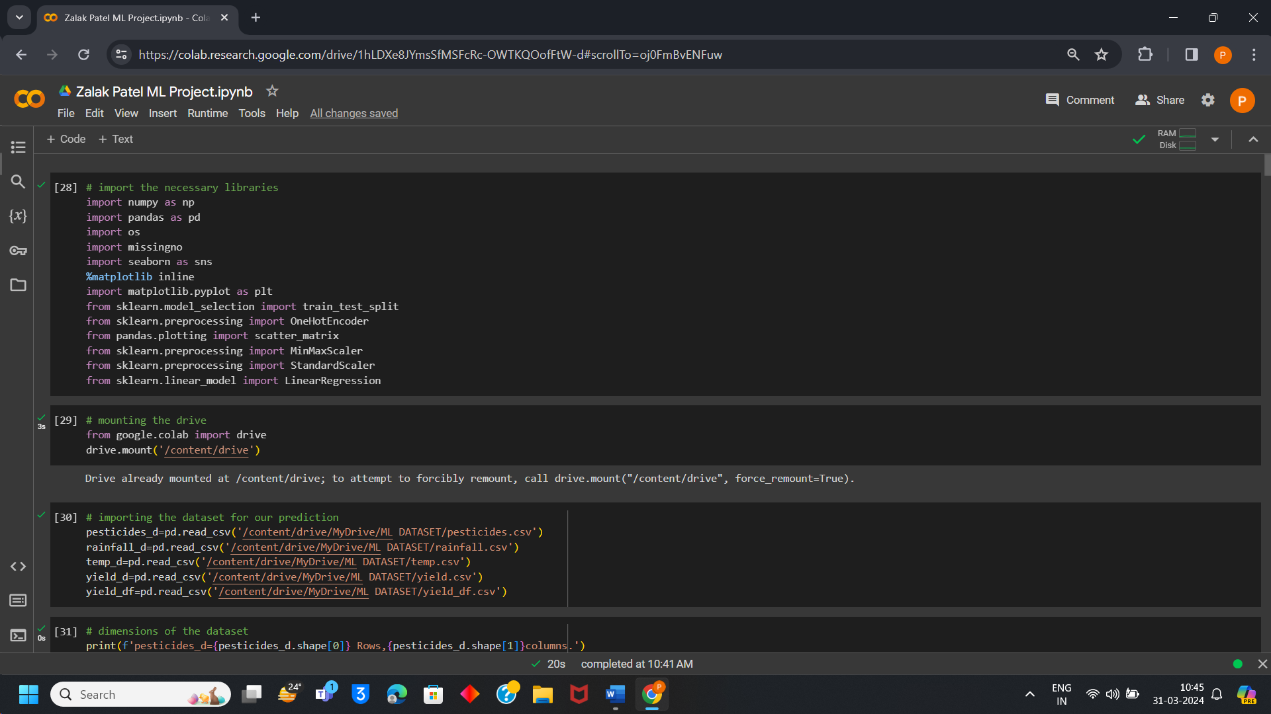

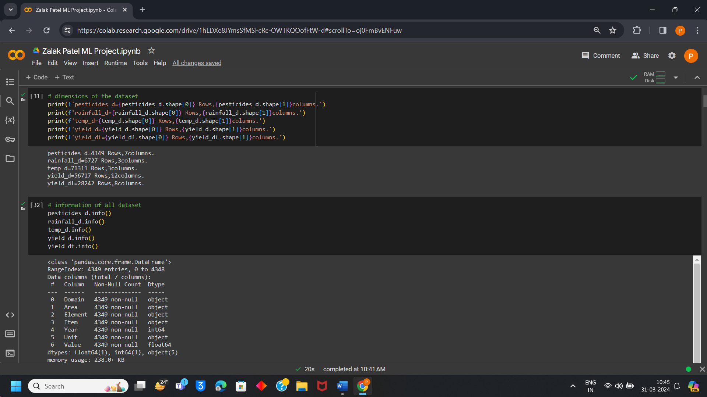

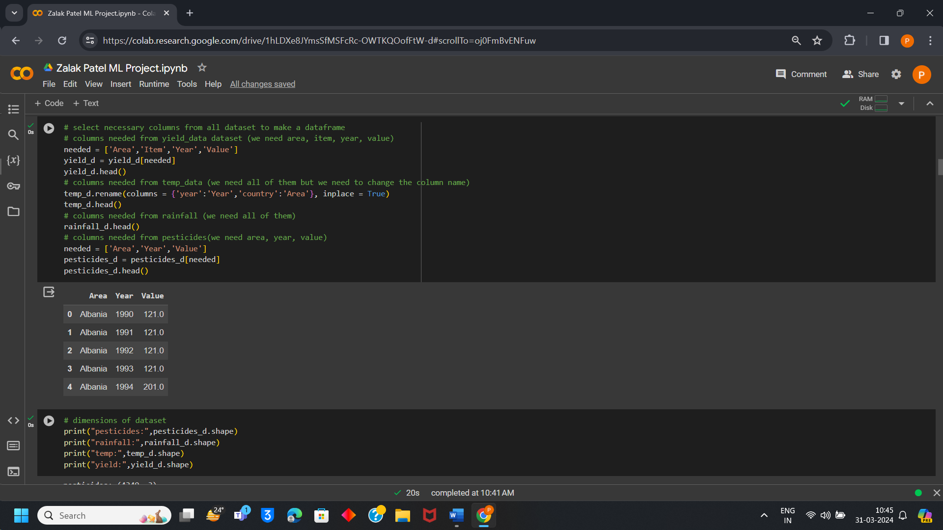

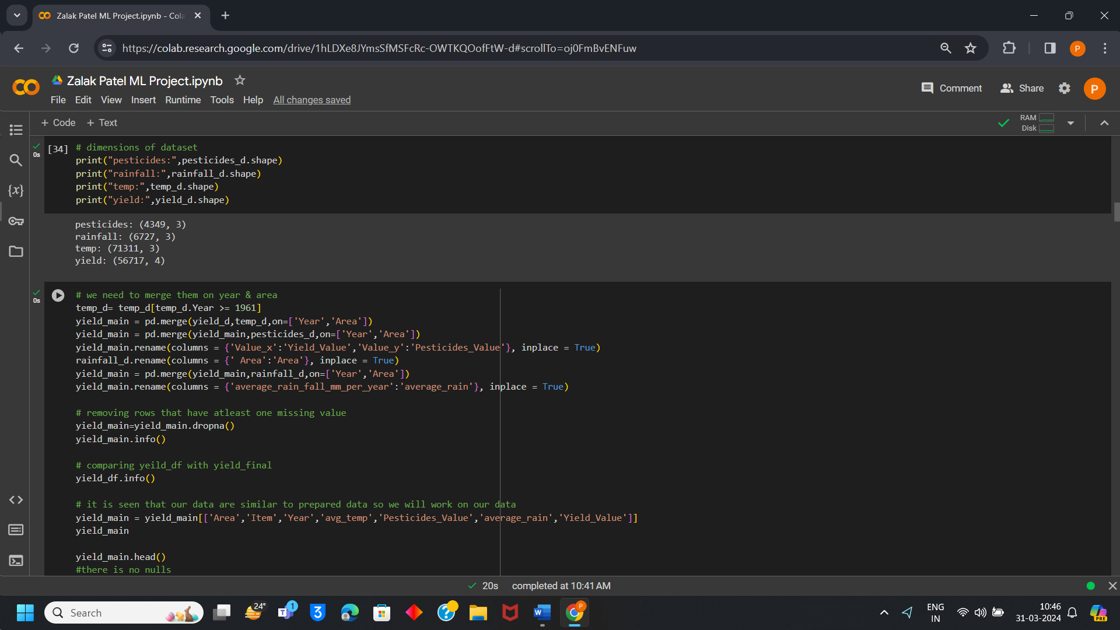

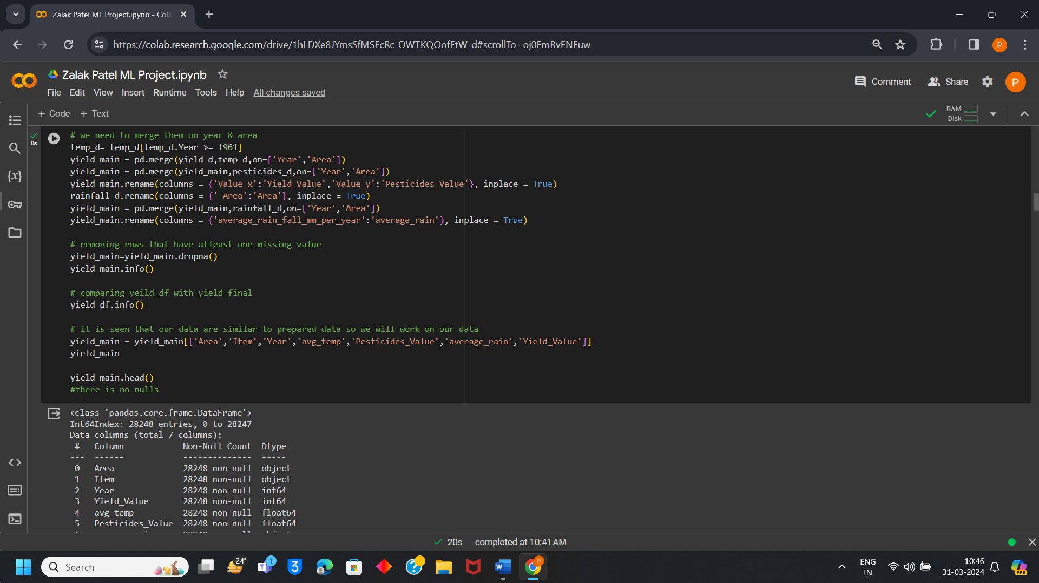

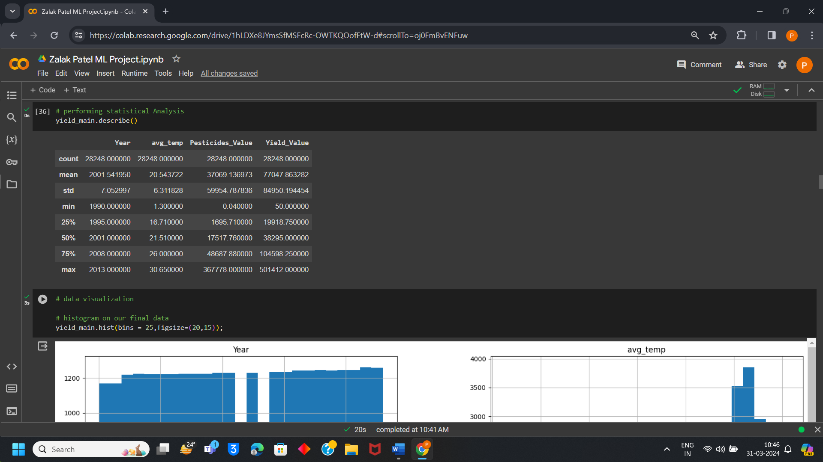

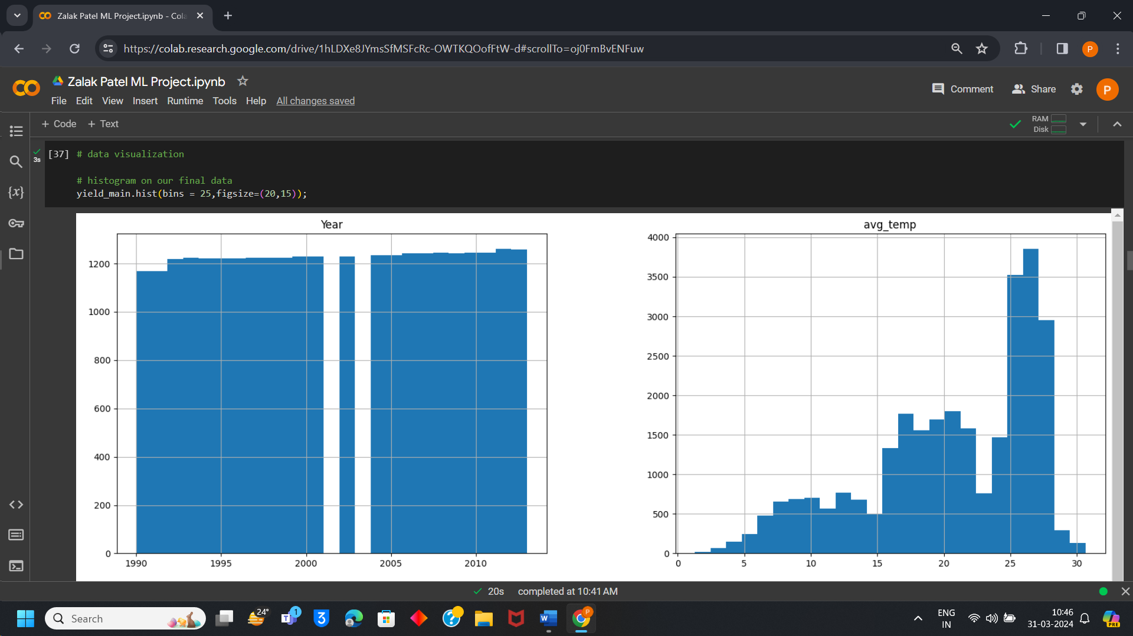

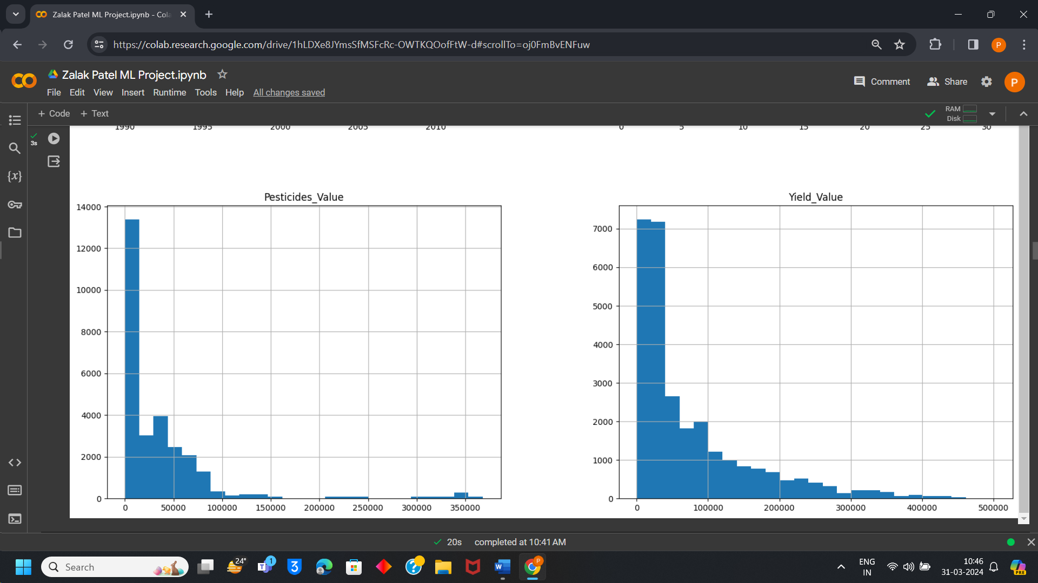

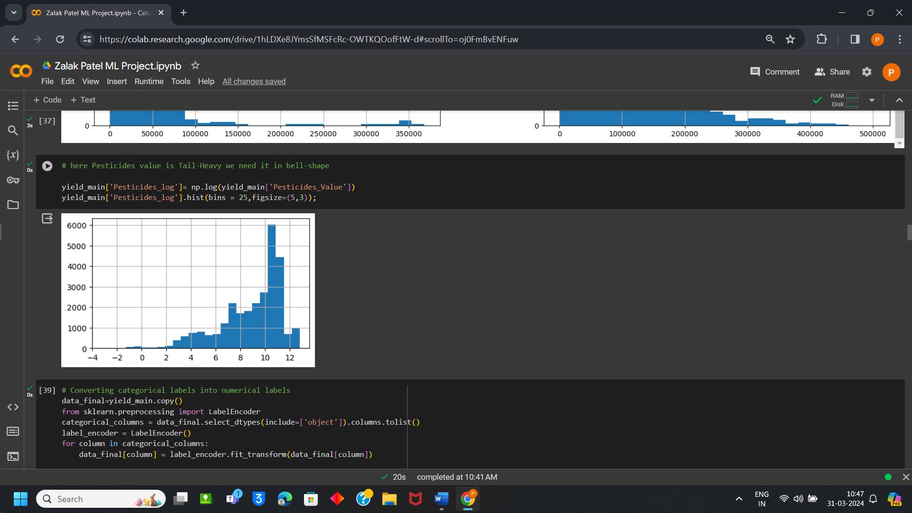

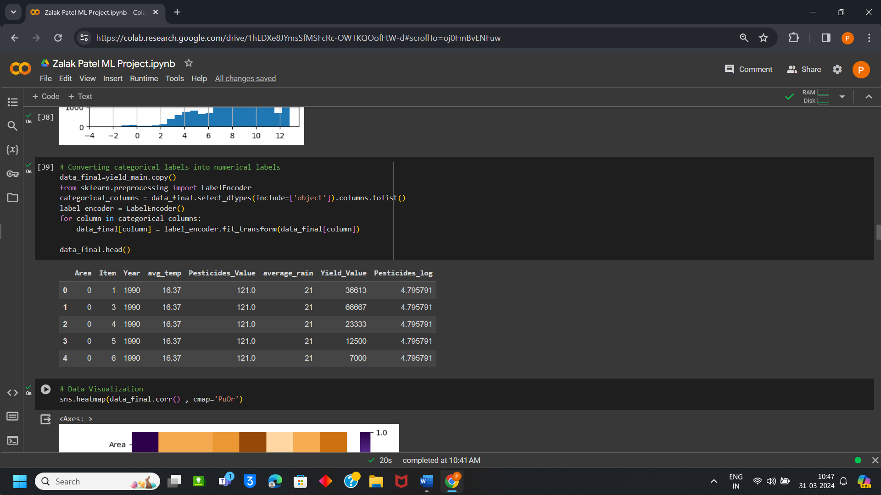

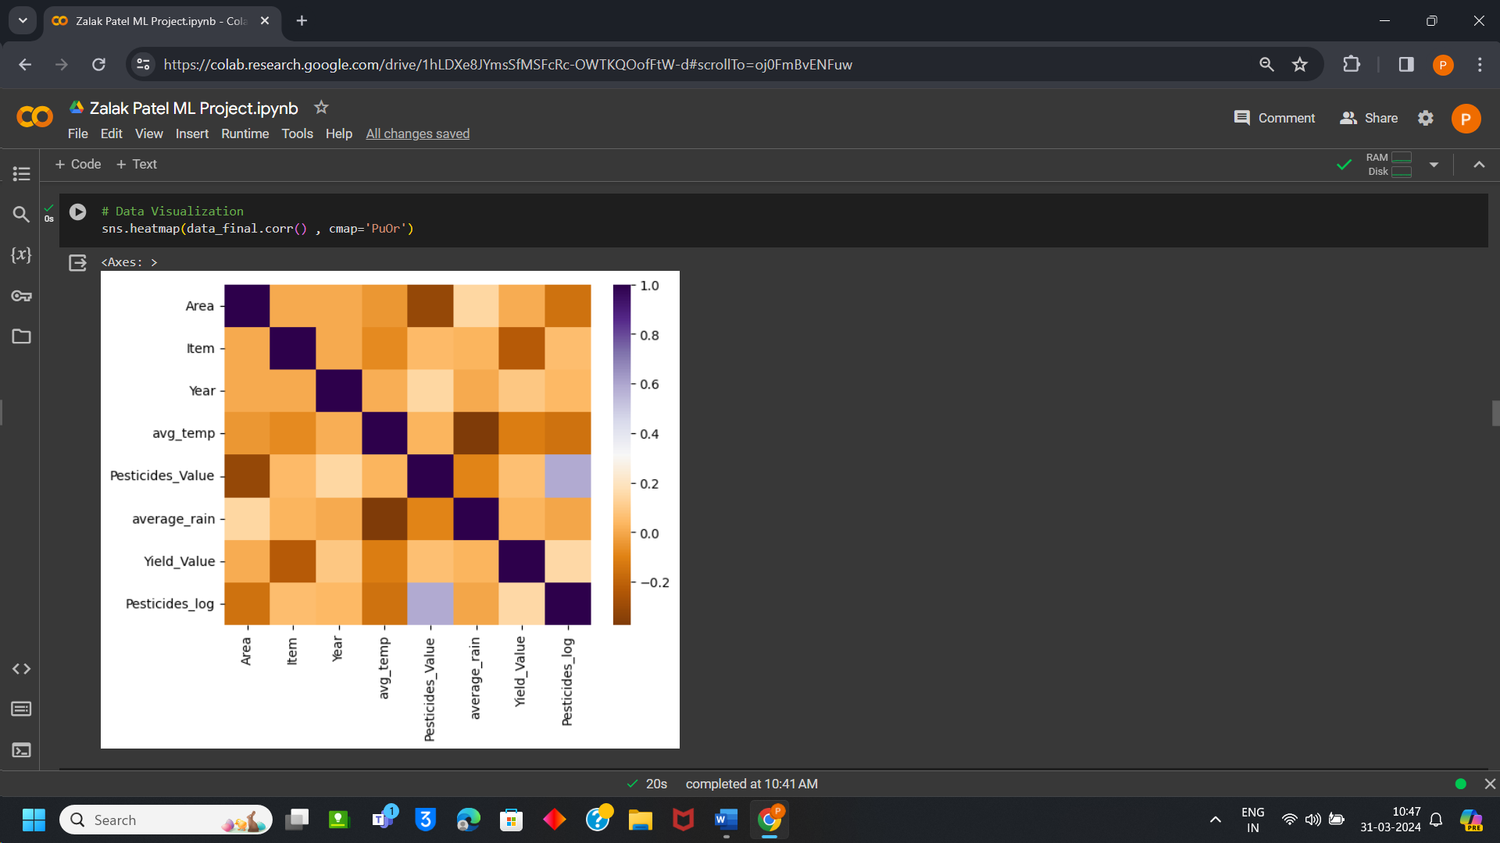

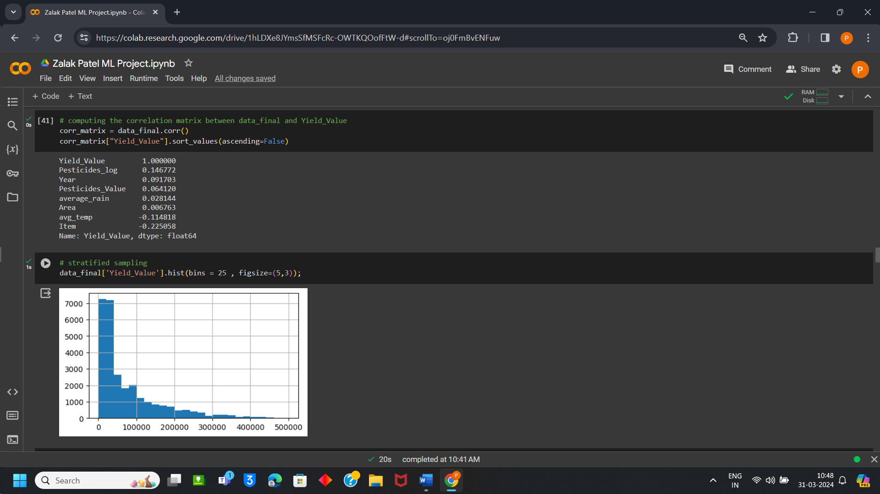

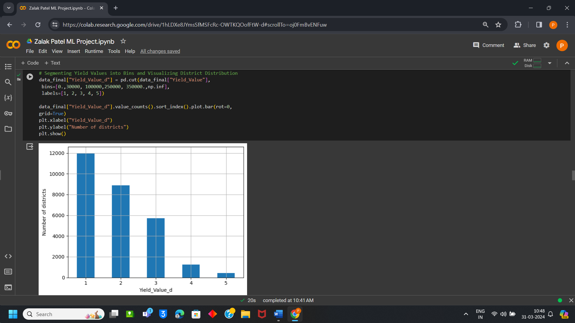

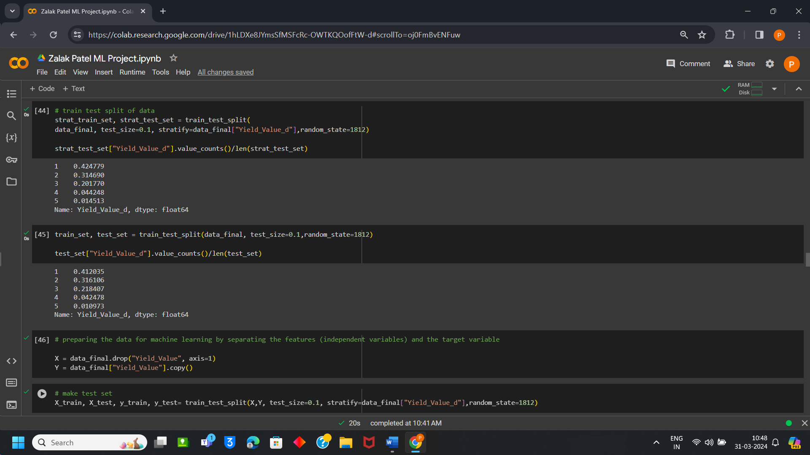

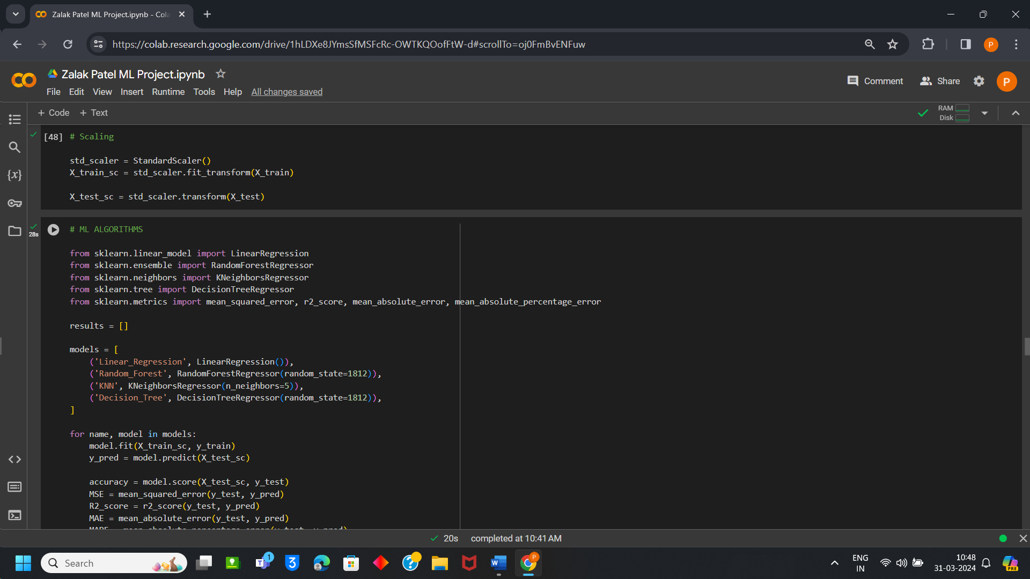

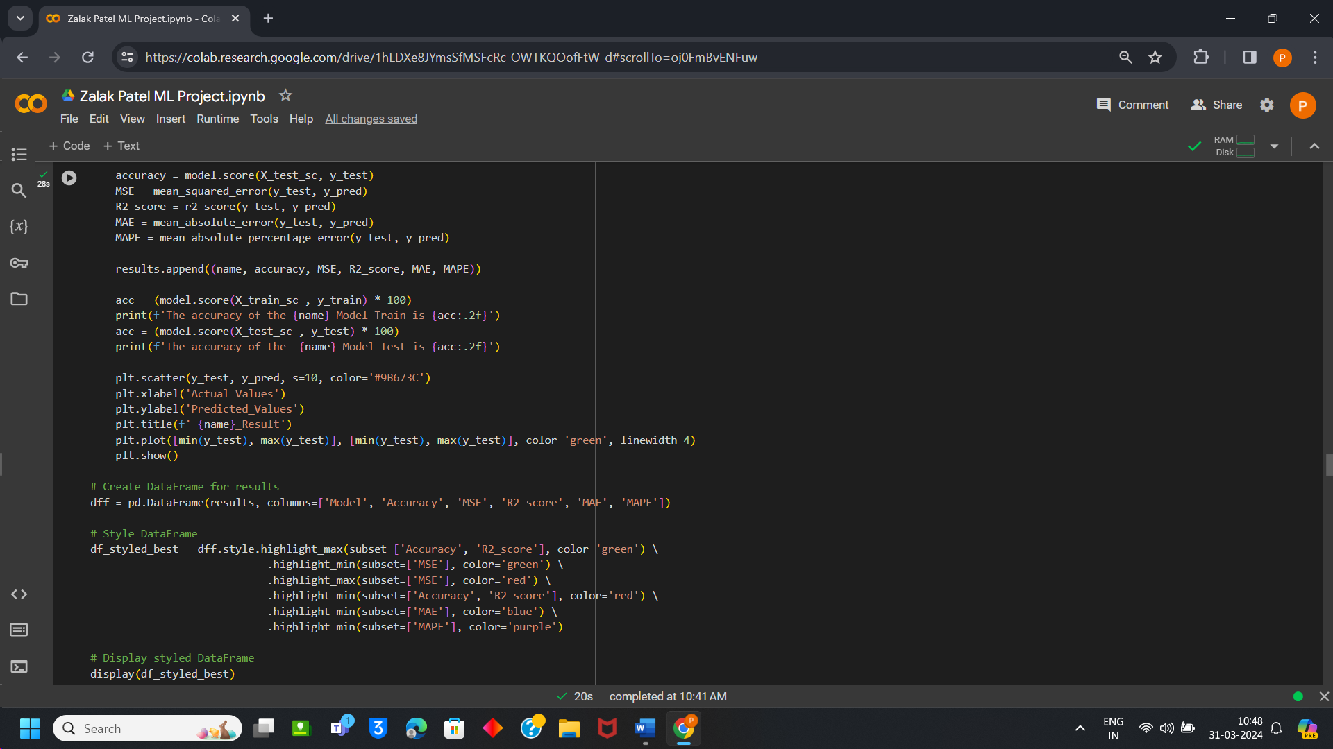

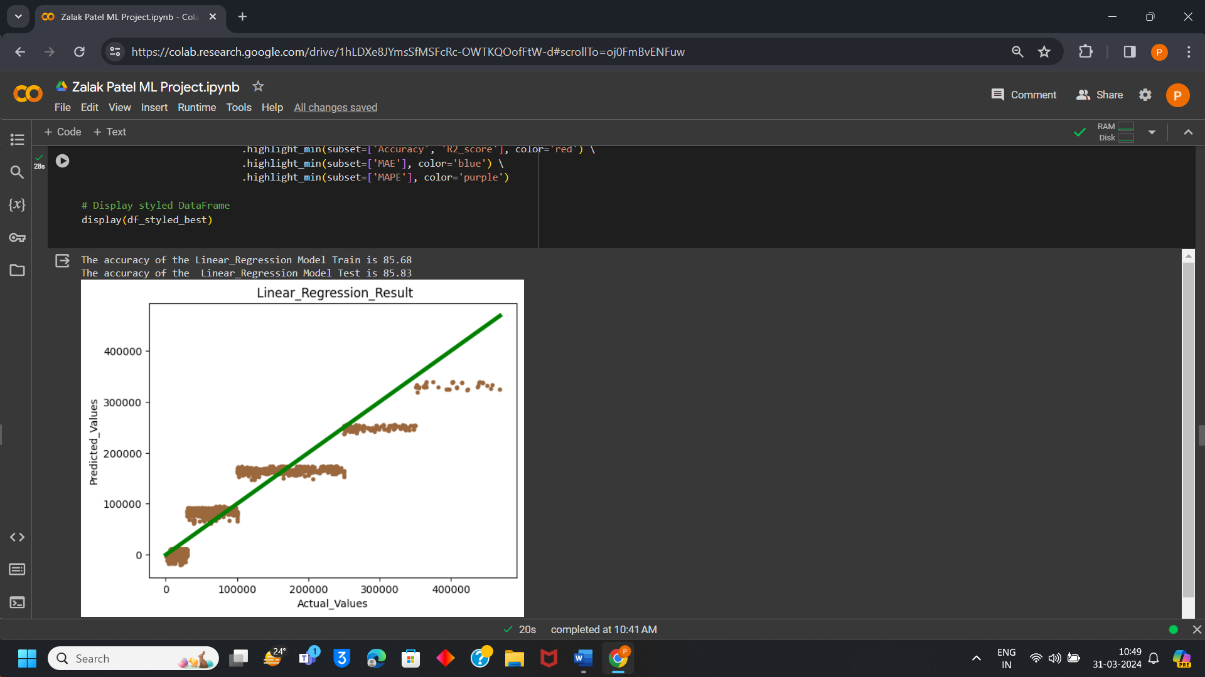

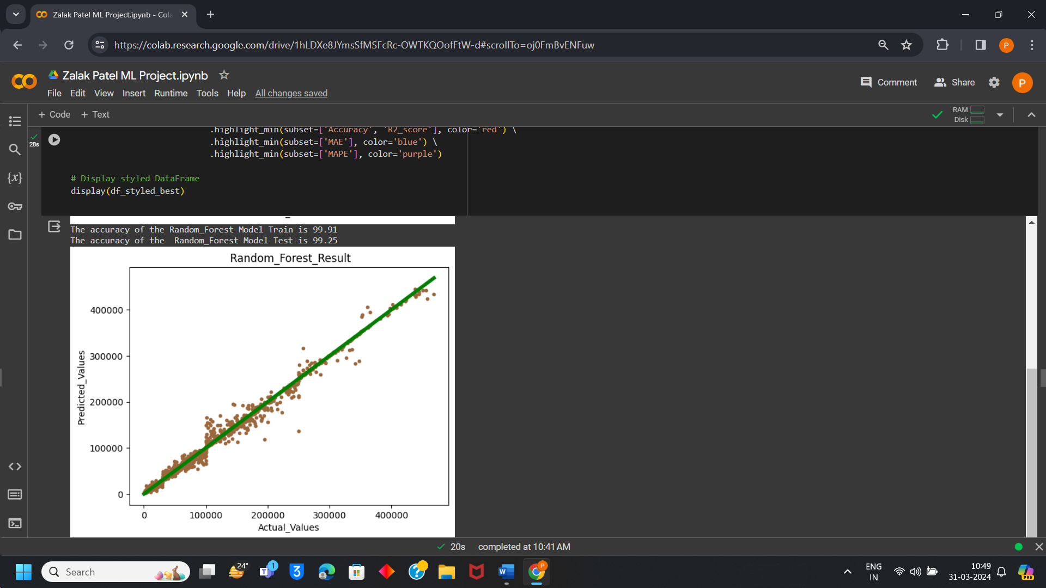

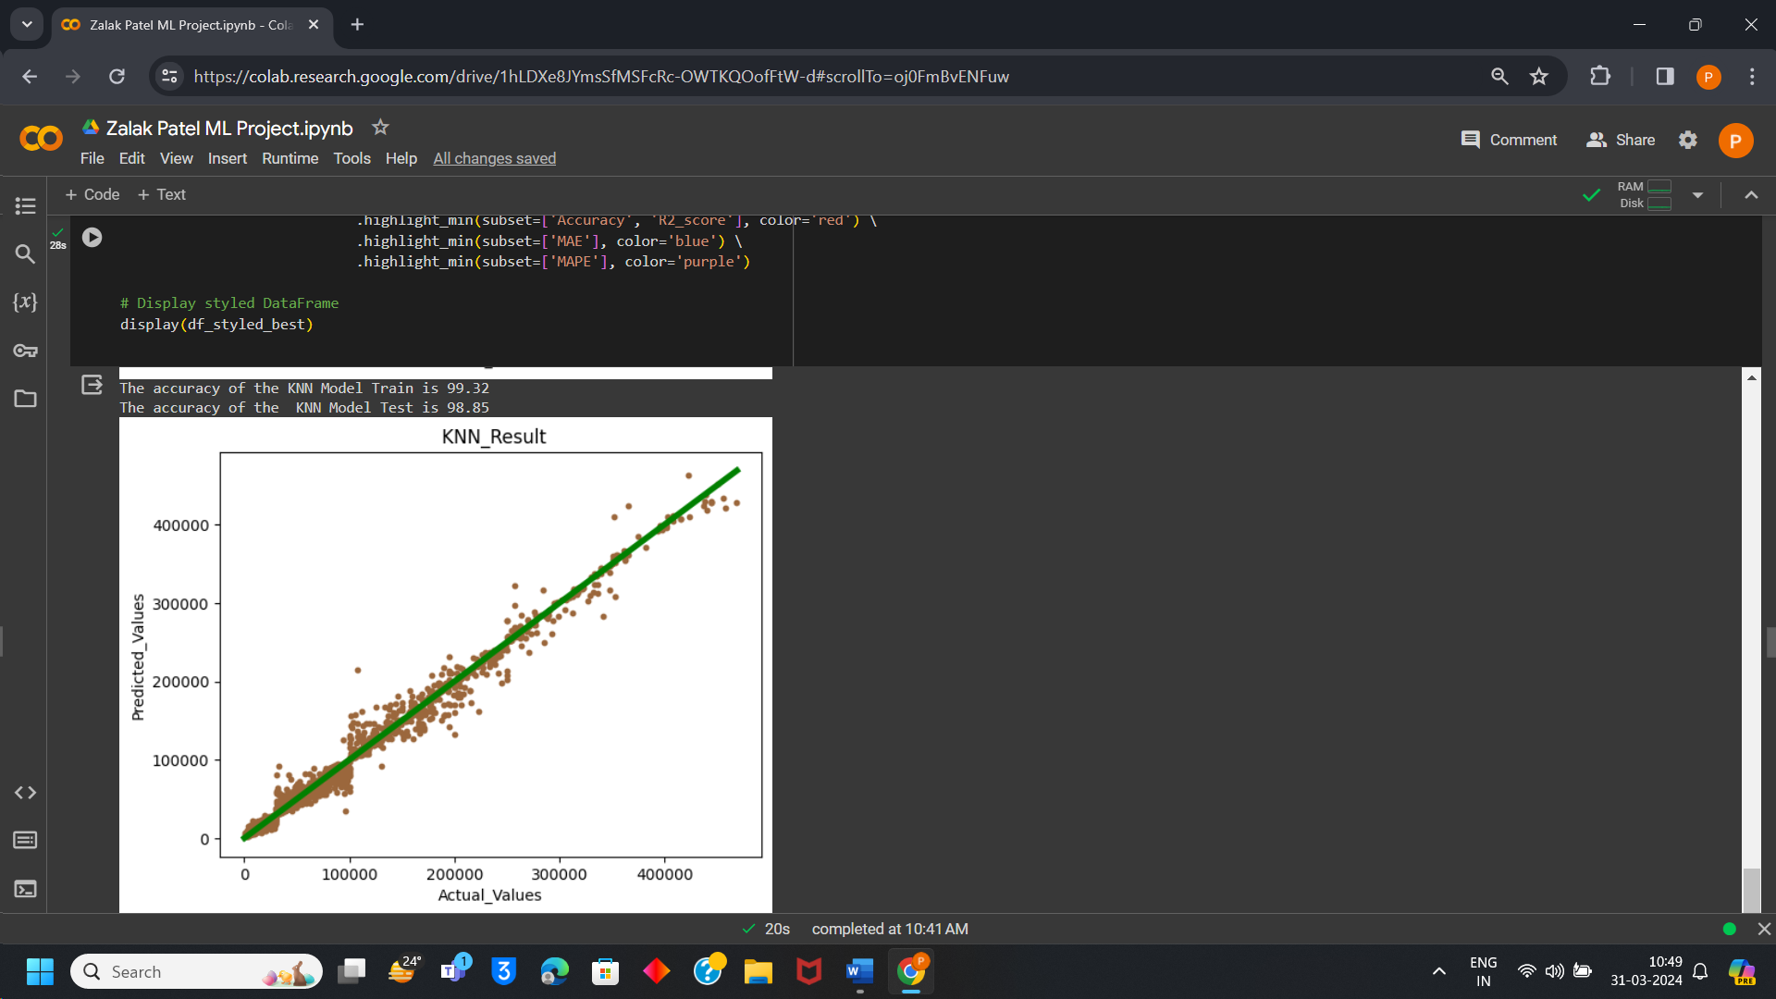

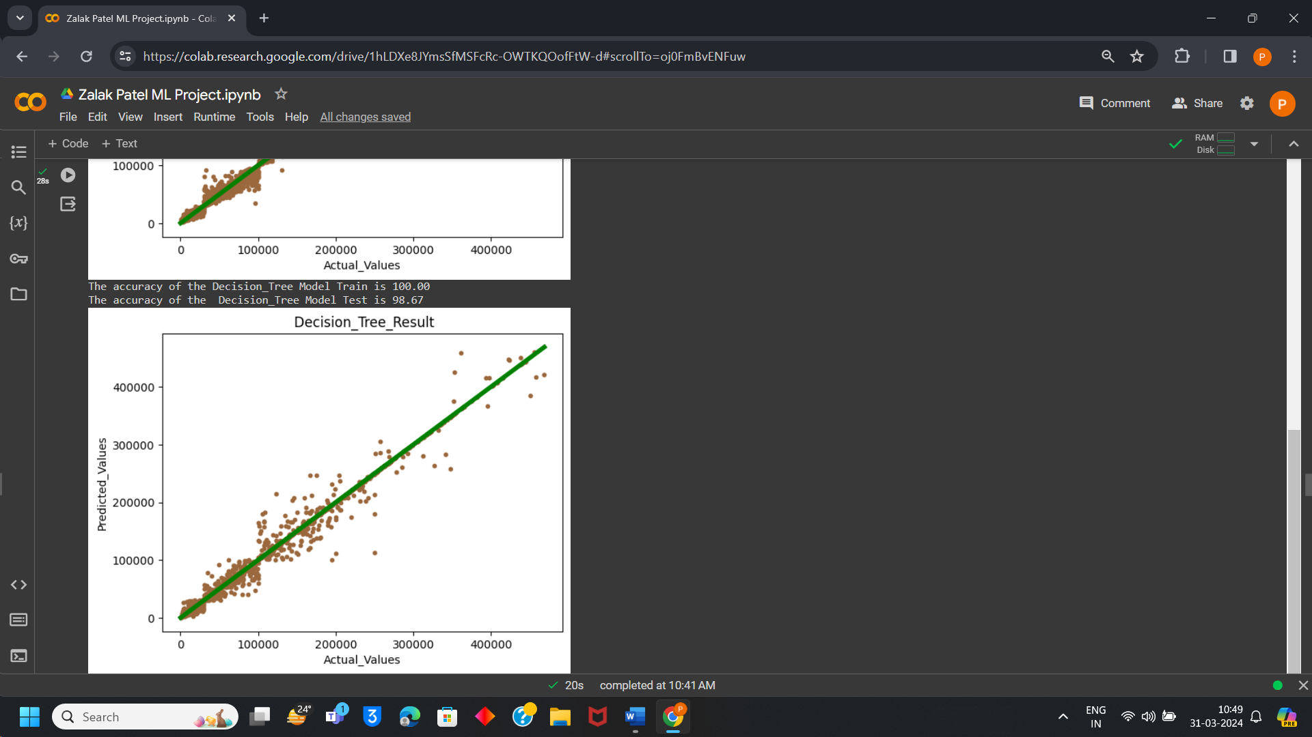

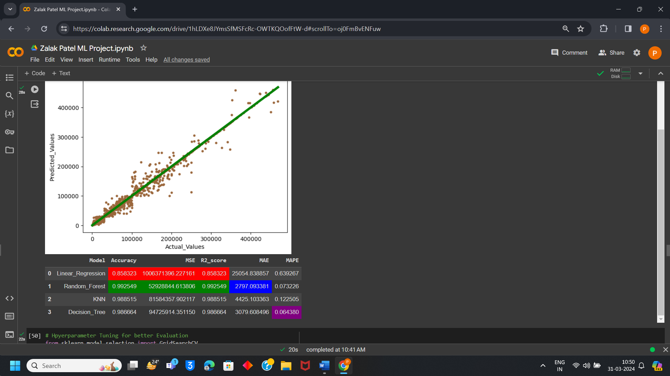

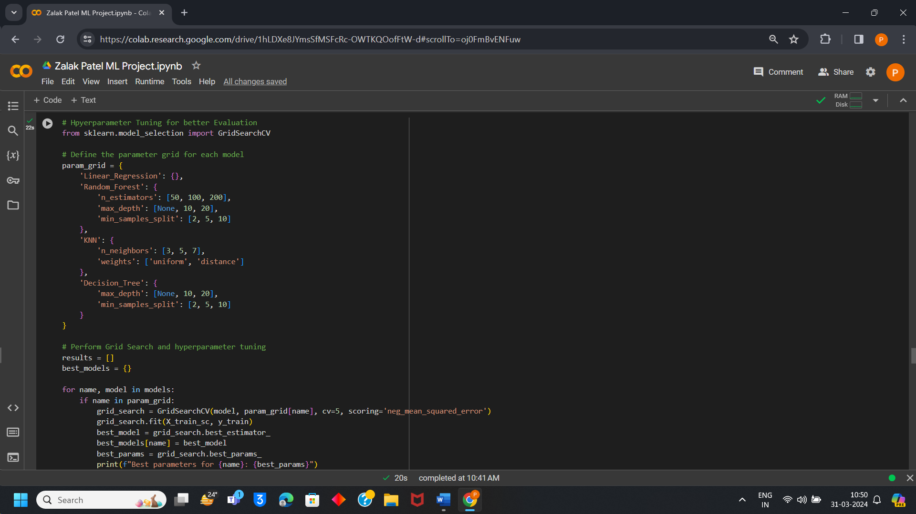

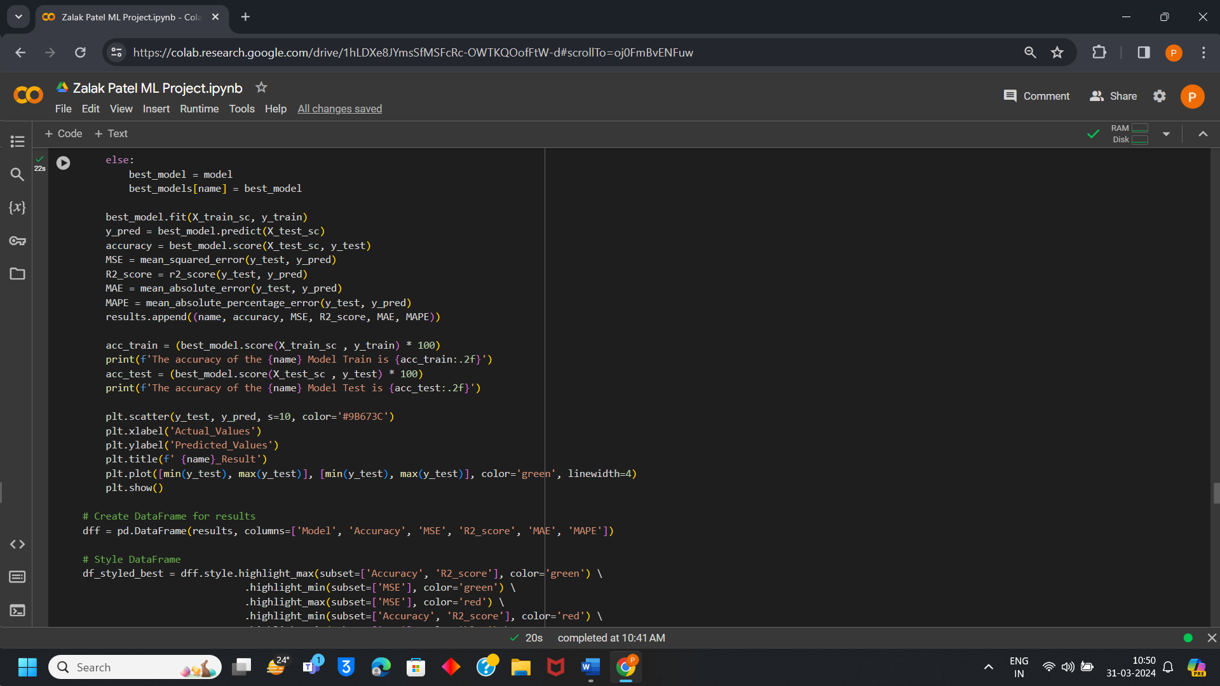

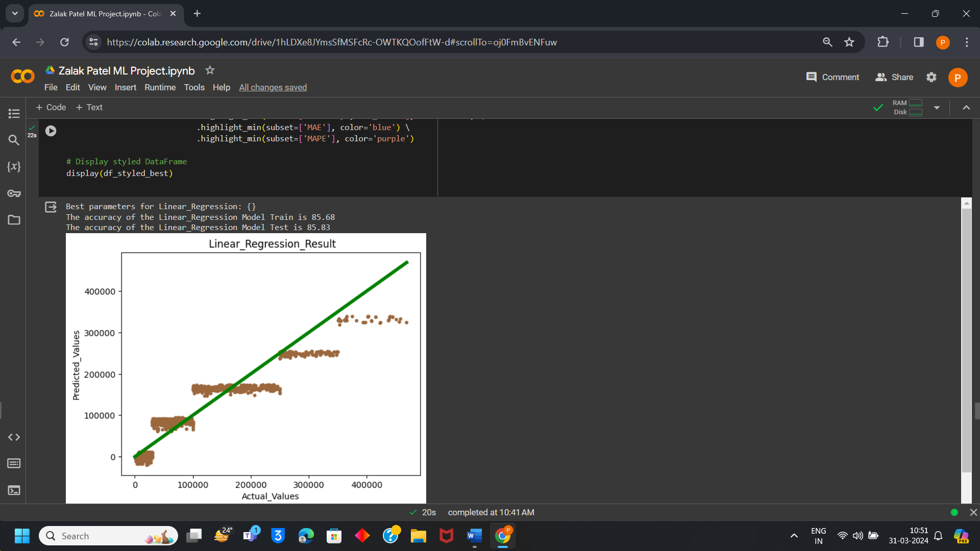

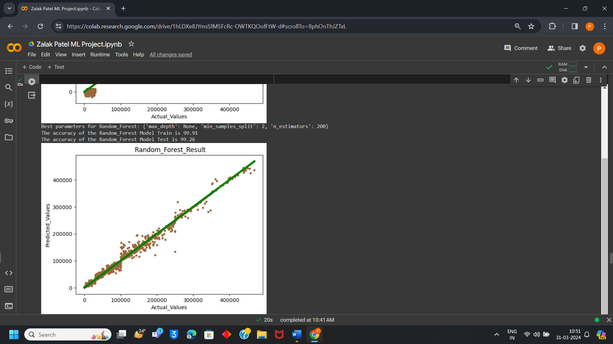

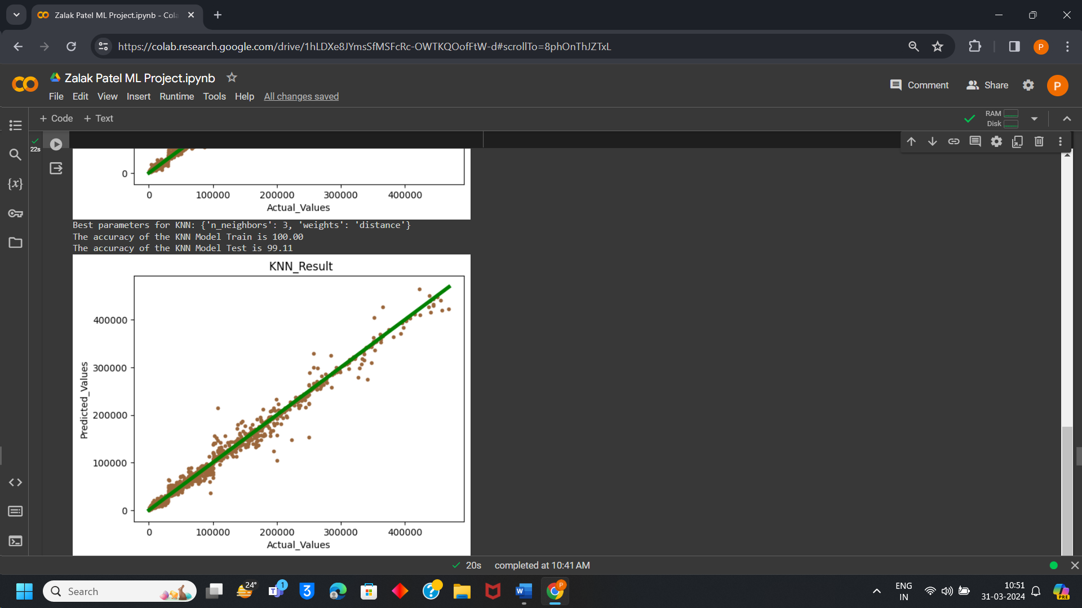

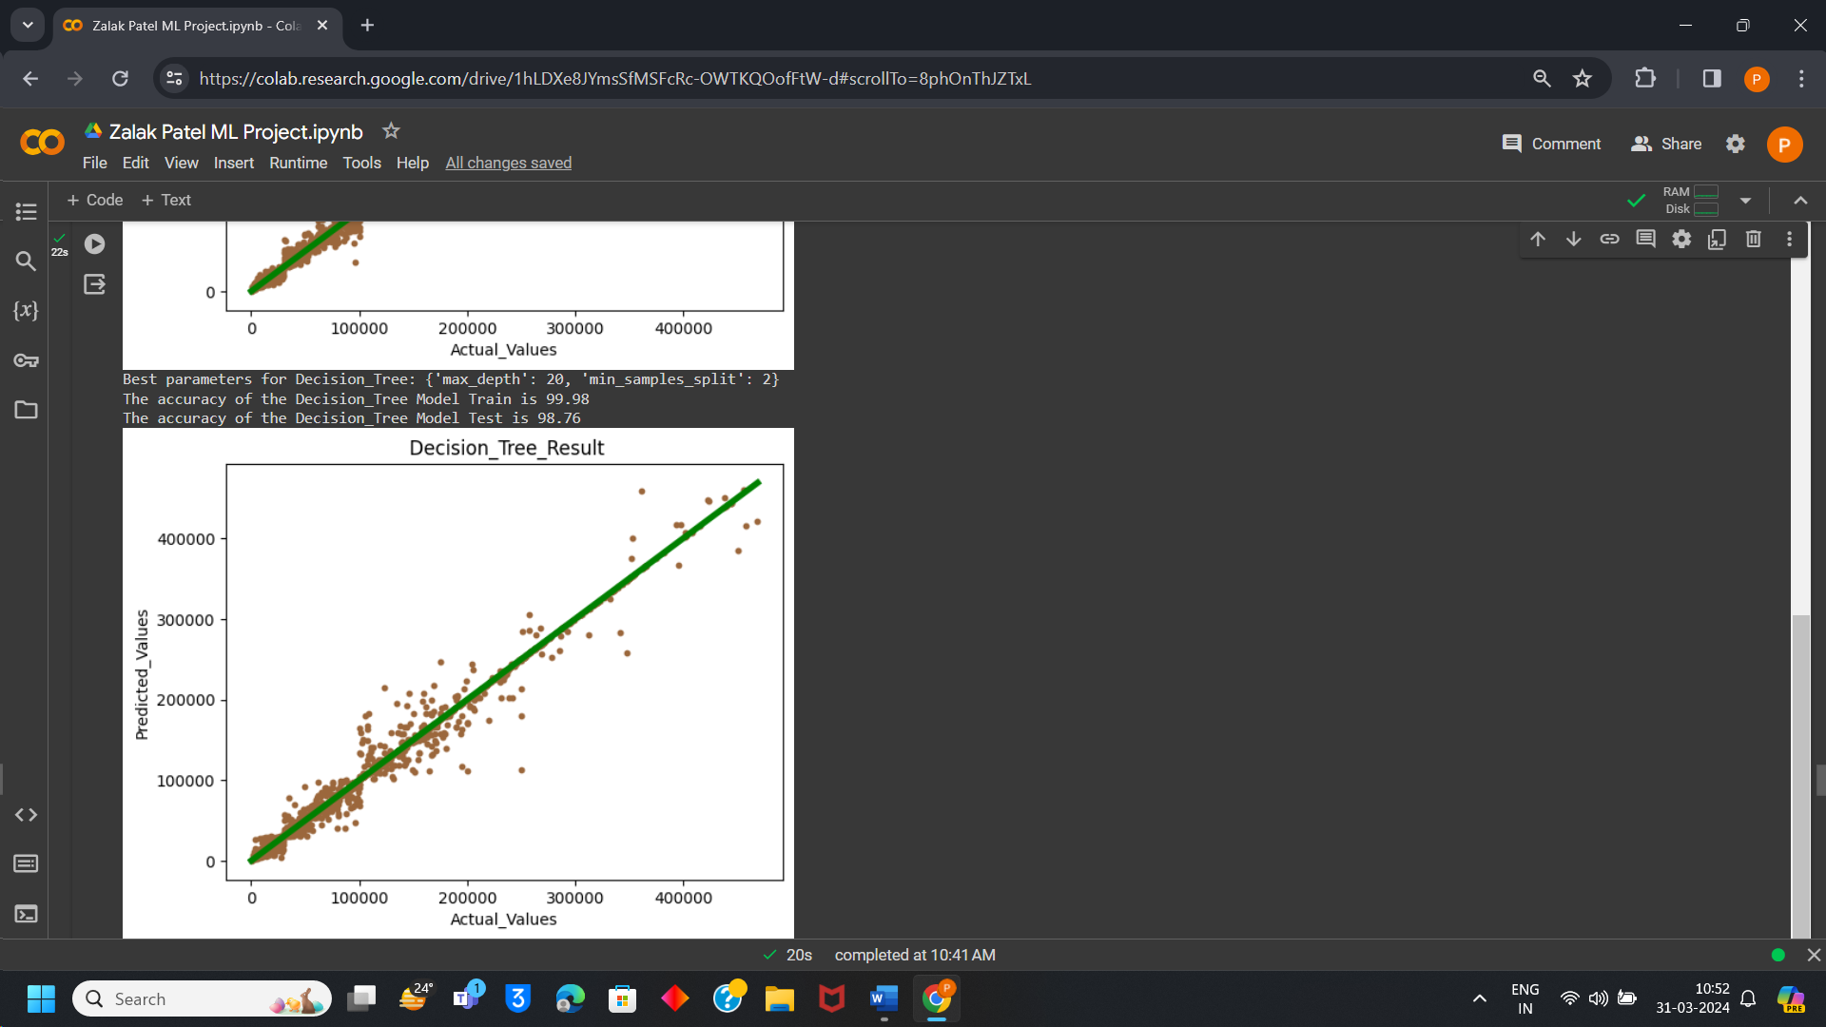

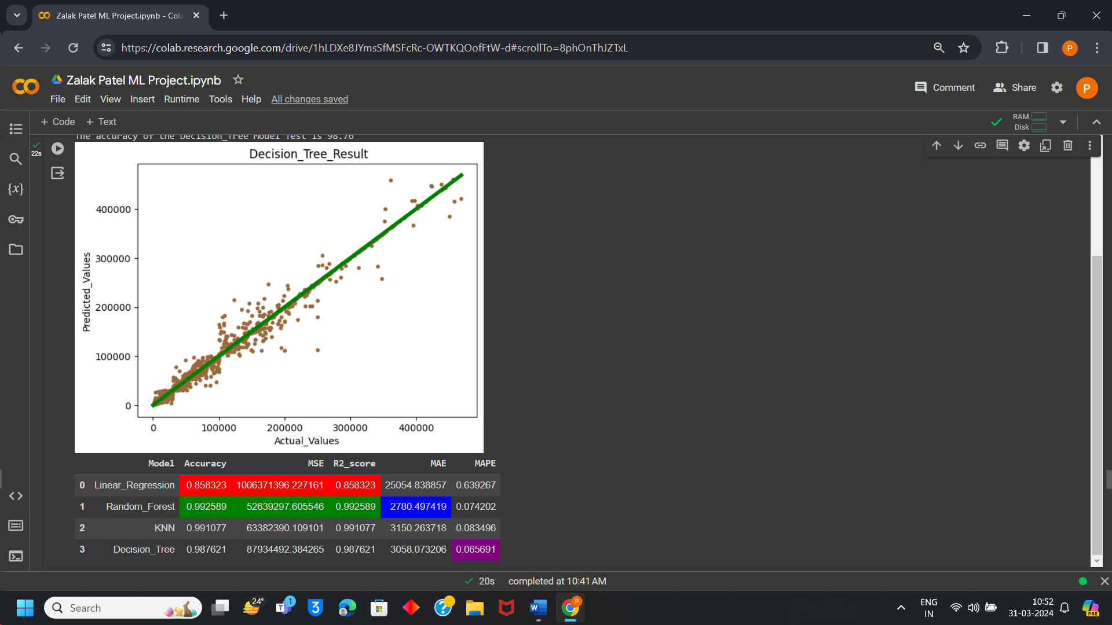

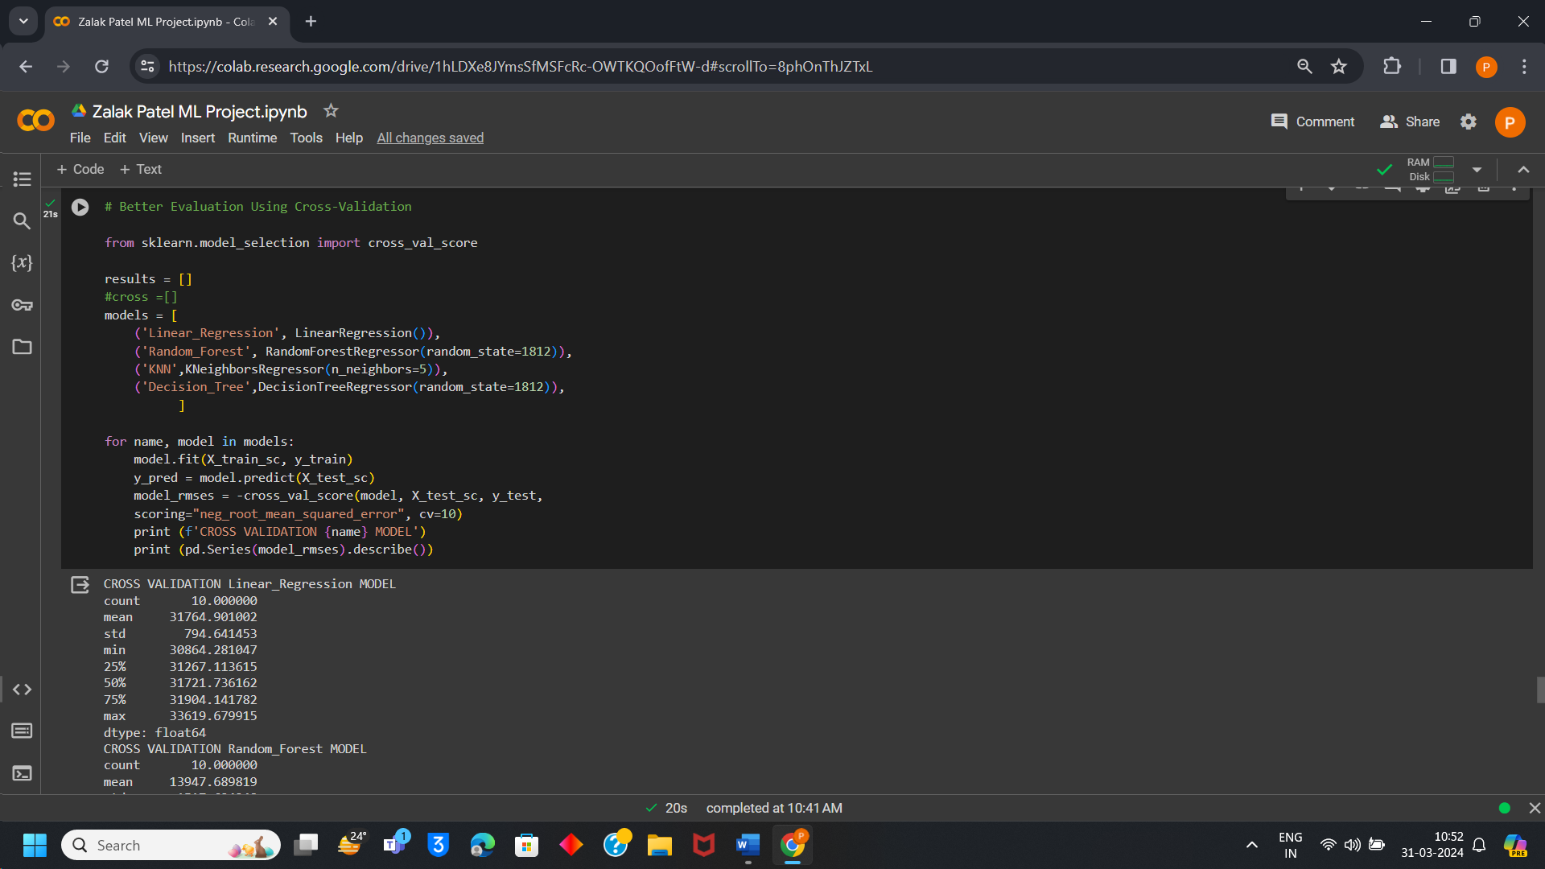

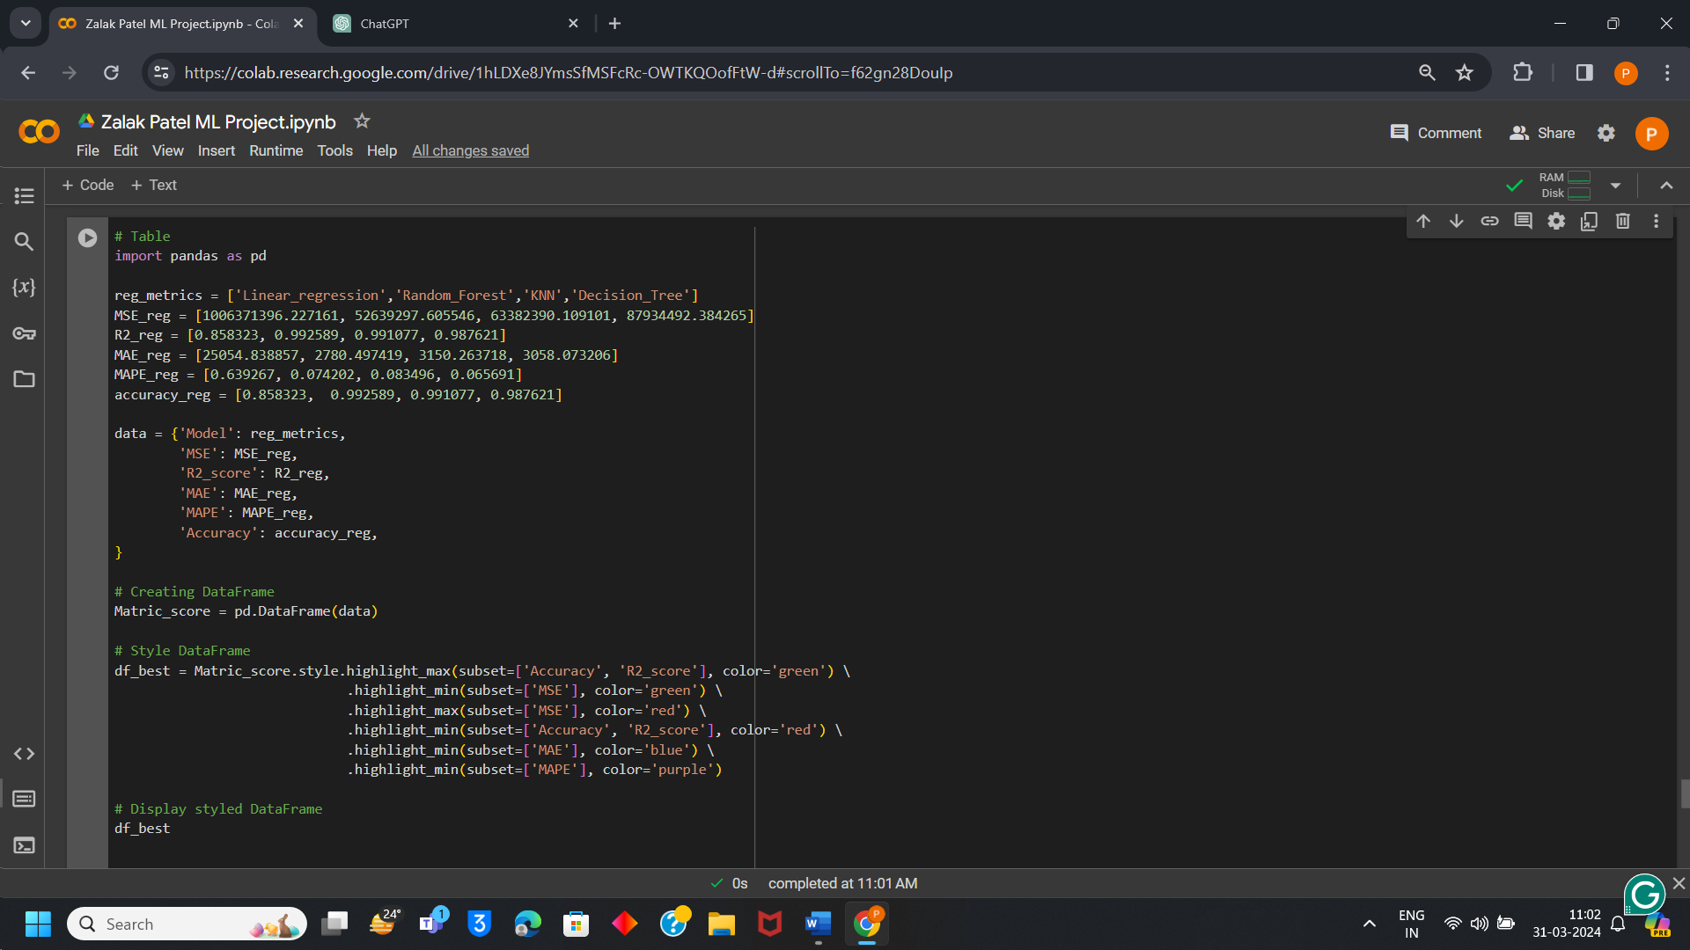

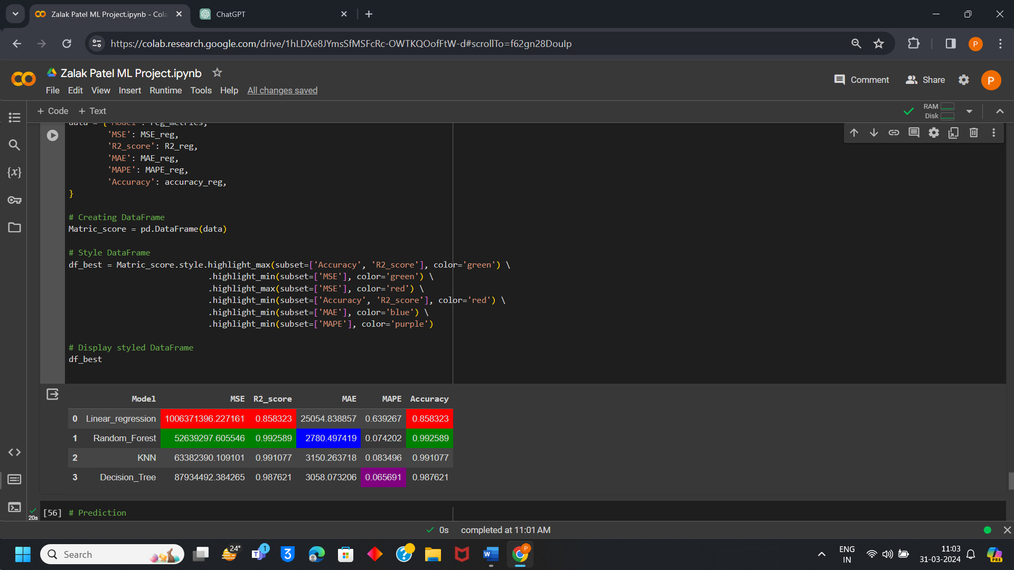

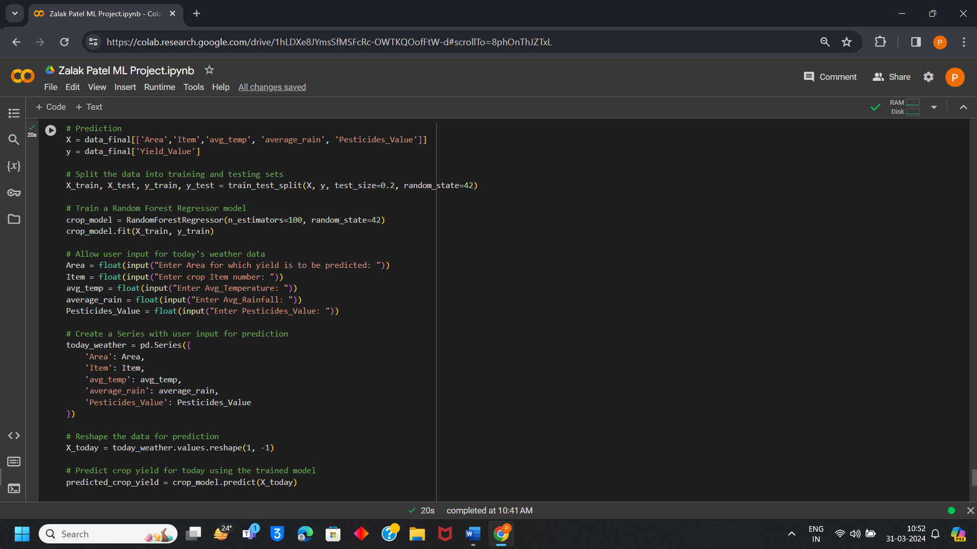

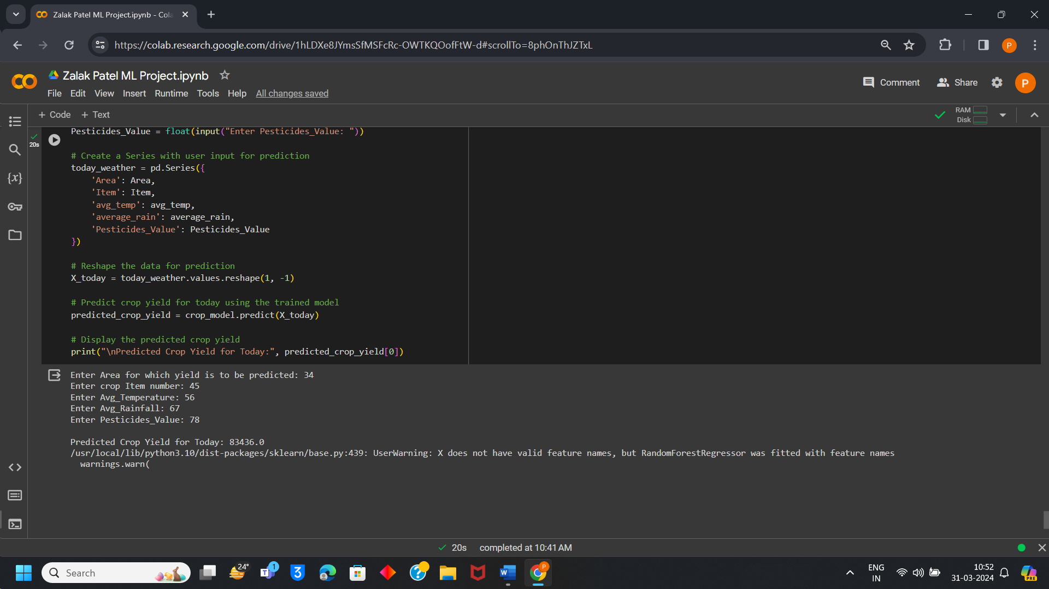

# OUTCOMES:

**CO1: Understand different machine learning techniques and its applications with respect to your project/case study problem statement.**

1.Linear Regression Algorithm

Algorithm Technique: Linear Regression Algorithm is used to identify linear Relationship between independent variables and dependent variables. Value which is to be predicted is known as dependent variable and value which is used to predict the outcome is known as Independent Variable. Value of one Variable can be predicted depending upon value of another variable.

Case Study Application: Here according to my project dependant variable is yield and pesticides, rainfall, temperature etc are known to be independent variable. Based on this factors of independent variable crop yield is predicted for instance if high temperature and balanced amount of pesticides are observed then it can result in increment in crop yields.

2.Random Forest

Algorithm Technique: Random forest is known for both classification and regression problems as it can handle both fluently in most of the cases. Combining the outcome of multiple decision trees Random Forest reaches to a single result. It is easy and flexible to use.

Case Study Application: Crop production may be predicted using a random forest model by taking into account variables like soil pH, humidity, temperature, rainfall, and crop type. In order to provide reliable predictions, each decision tree in a forest takes into account a random selection of characteristics and data points. Compared with individual decision trees, random forests are not as prone to overfitting and can accommodate a high number of input characteristics. It is skilled at handling non-linear characteristics and correlations and can identify complex relationships among characteristics and yields of crops.

3.KNN

Algorithm Technique: The technique of k-nearest-neighbours (KNN) is a simple approach that works well for classification and regression applications. A random, supervised learning classifier, the k-nearest-neighbours (KNN) technique use similarity to classify or predict how a single data point will be grouped.

Case Study Application: KNN uses historical data to identify the K closest nearby fields for a particular set of environmental parameters, such as rainfall, temperature, and soil nutrients. The crop production of the present field is then predicted using the average yield from these nearby fields.

4.Decision Tree:

Algorithm Technique: Recursively dividing the feature space according to the most informative characteristics, decision trees are simple models. They can handle both category and numerical data, and they are simple to comprehend. A not parametric supervised learning approach that is used for both regression and classification applications is the decision tree. With the root node, branches, internal nodes, and leaf nodes, it has a hierarchical tree structure.

Case Study Application: To estimate agricultural yield, a decision tree may first divide the data according to the most important characteristic (temperature, for example). Every split after that improves the forecast even further by taking into account other elements like soil nutrients and rainfall. The nodes of the leaves in a tree, where every leaf represents a unique combination of feature values, are where the ultimate predictions are produced.

**CO2: Understand the importance of simple linear regression in predicting new observations with respect to your project/case study. Can Simple Linear Regression can be used for your problem? Yes/No Explain why?**

It is possible to estimate crop production using simple linear regression, however its relevancy may be restricted based on the particular situation and problem's complexities. The basic idea of simple linear regression is that the variable that is dependent (outcome) and one independent variable (predictor) have a linear relationship. If there is a strong and linear association between just one predictive variable and crop yield.

In this case, basic linear regression may be useful if historical data indicates a linear connection among temperature and crop output—that is, if crop yield grows or decreases linearly with temperature. Here, crop yield might be the dependent variable and temperature the independent variable.

However, in the majority of real-world situations, a variety of elements, including temperature, precipitation, sunshine, soil quality, pests, diseases, etc., affect crop production. These variables frequently interact in intricate ways, and there may be a non-linear relationship between them and crop output.

Because of this, basic linear regression may not fully represent the complexity of the issue, even while it may be used to forecast crop output in very constrained cases when there is a straightforward linear connection between a single predictor variable and the outcome of the crop.

**CO3: Understand the importance of Multiple linear regression in predicting new observations with respect to your project/case study. Can Multiple Linear Regression can be used for your problem? Yes/No Explain why?**

Indeed, crop production prediction using Multiple Linear Regression (MLR) is a common practice in crop studies and yield predictions.

Multiple variables may be incorporated simultaneously using MLR, including weather (temperature, humidity, rainfall, etc.), soil characteristics (nutrients, pH, texture), crop management techniques (fertilization, irrigation), and other environmental aspects. A multitude of factors influence crop output; multiple linear regression (MLR) allows us to capture the combined effect of these factors on yield.

Multiple predictor factors and crop yield may be quantitatively analyzed thanks to MLR. MLR assists us in determining the strength and direction of each predictor variable's impact on crop output by calculating its coefficients for each one. This makes it possible to make data-driven decisions about agricultural methods.

MLR is adaptable for integrating many types of data that are frequently found in agriculture since it is capable of handling both number and category predictor variables. For instance, numerical factors like temperatures or moisture in the soil can be combined with category variables like crop kind or insect infestation levels.

When compared to more intricate machine learning techniques, MLR models are comparatively simple to understand. The MLR equation's coefficients offer clear insights into how variations in every predicted variable impact the anticipated crop output. For those interested with agriculture, such as farmers, agronomists, and legislators, this interpretability is useful.

Because MLR models are transparent, it is simpler to evaluate the prediction performance of the model and validate its assumptions. The accuracy of the model used for MLR may be enhanced by assessing and improving its dependability using methods like cross-validation and residual analysis.

**CO4: For your project definition, explain the importance of parameter estimation. Check how it affects the overall results when you change the values of different parameters.**

Since parameter estimation measures the correlations between predictor factors (such weather and soil characteristics) and crop production, it is essential for forecasting agricultural yield. It makes it possible to read models accurately, make predictions with precision, adapt to changes in the environment, and generalize to new data. Precise parameter estimations result in dependable forecasts, well-informed farming choices, and enhanced production and sustainability in the agricultural sector.

**CO5: Compare different Machine Learning algorithms used for your project/case through evaluation metrices. Show which ML algorithm works best for your problem.**

Evaluation metrics after model Implementation

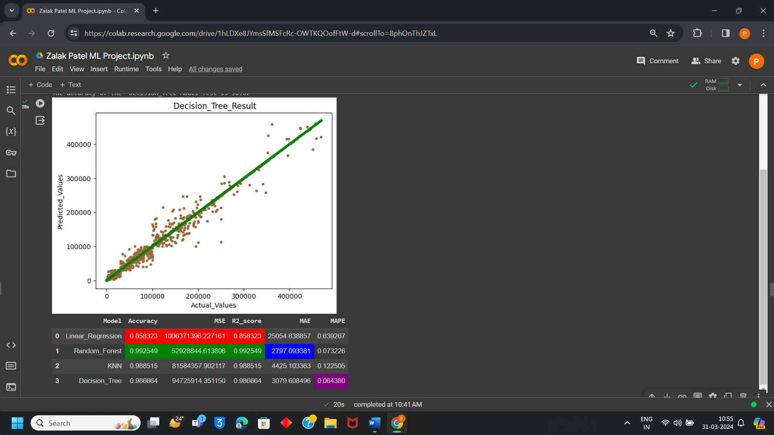

Evaluation Metrics after Hyperparameter Tuning

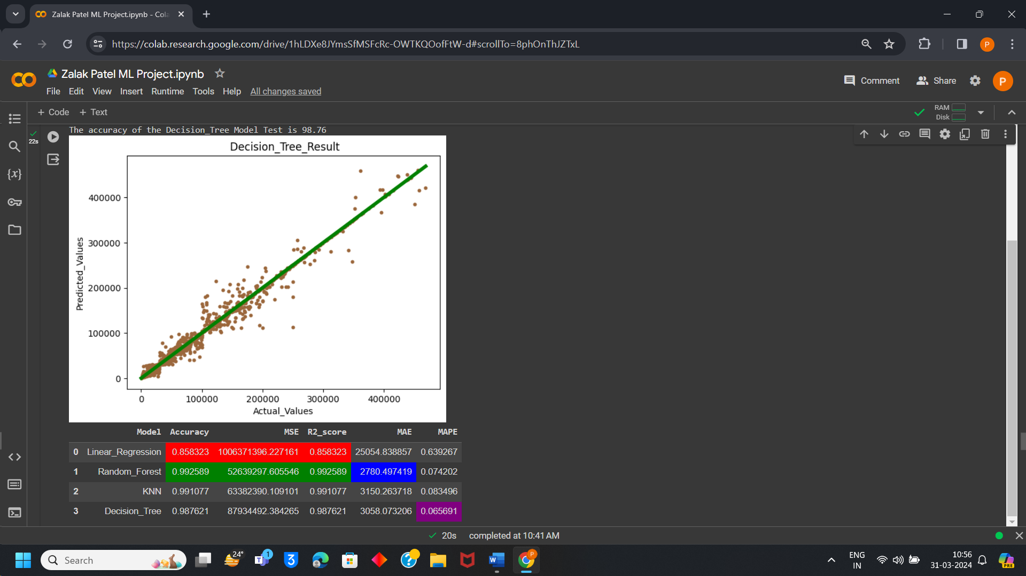

Comparison Table:

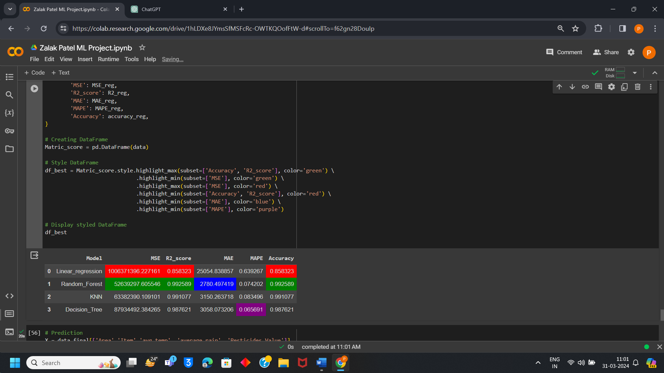

# Conclusion:

From the above project of Crop Yield Prediction it can be seen that among all 4 algorithms such as Linear Regression, Random Forest, K Nearest Neighbor, Decision Tree the most accurate for this project on predicting crop yield is Random Forest Algorithm as its accuracy is around 99% which is the highest accuracy then all other algorithms.

K nearest Neighbour and Decision tree are also accurate that is around 99% and 98% but Random Forest is more Accurate then this two algorithms. Whereas Linear Regression is the lowest among all four in accuracy which is 85% so it can be considered least accurate model for crop yield prediction.

Hence, it is clearly visible that Random Forest is best fitted for Crop Yield Prediction and it can give accurate result for yield prediction on bases of factors such as rainfall, temperature, pesticides etc. So, Random Forest is used for prediction as it gives accuracy and farmers can be benefitted.